[**P**](https://github.com/laureinabbie/Programming-Assignment-3)**rogramming Assignment 3 Simulations**

**Condition 1:**

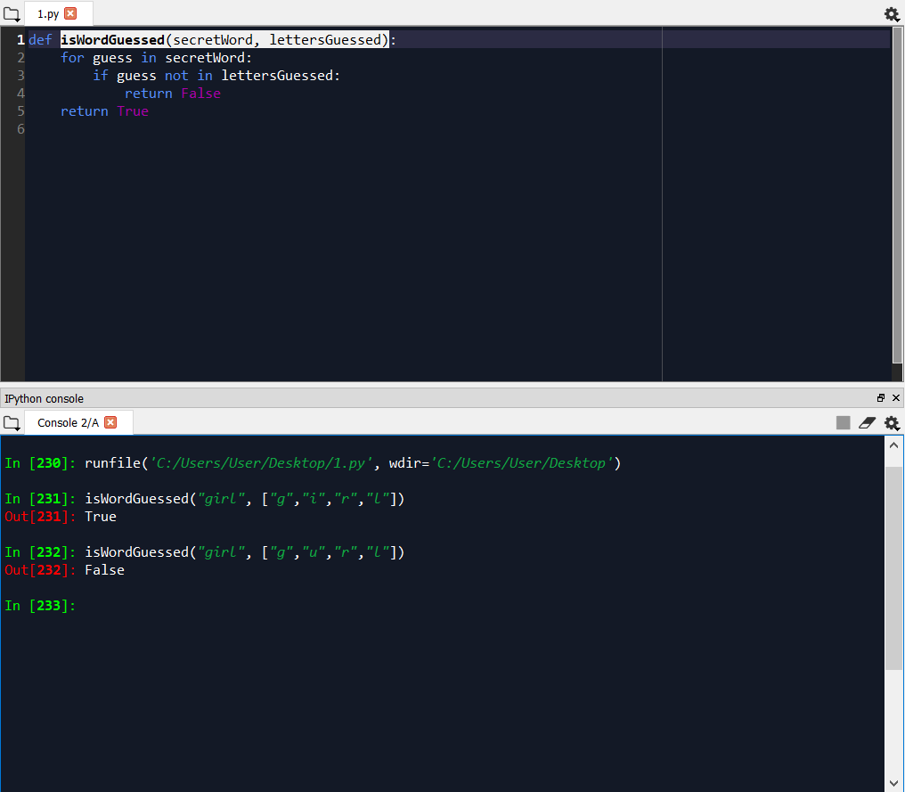

Word Used: girl

-If a letter in the list is found in the secret word, it outputs True, otherwise, False.

**Condition 2:**

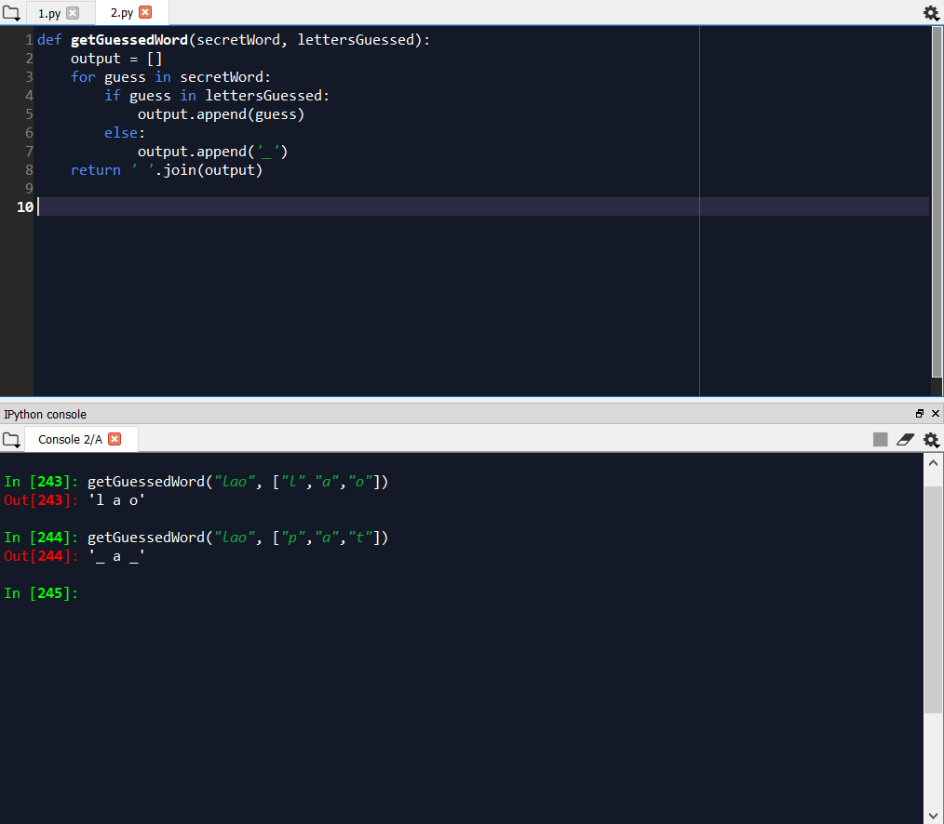

Word Used: lao

-If a letter guessed by the user is correct, it is displayed by the program. Otherwise, the letter guessed mistakenly is left blank.

**Condition 3:**

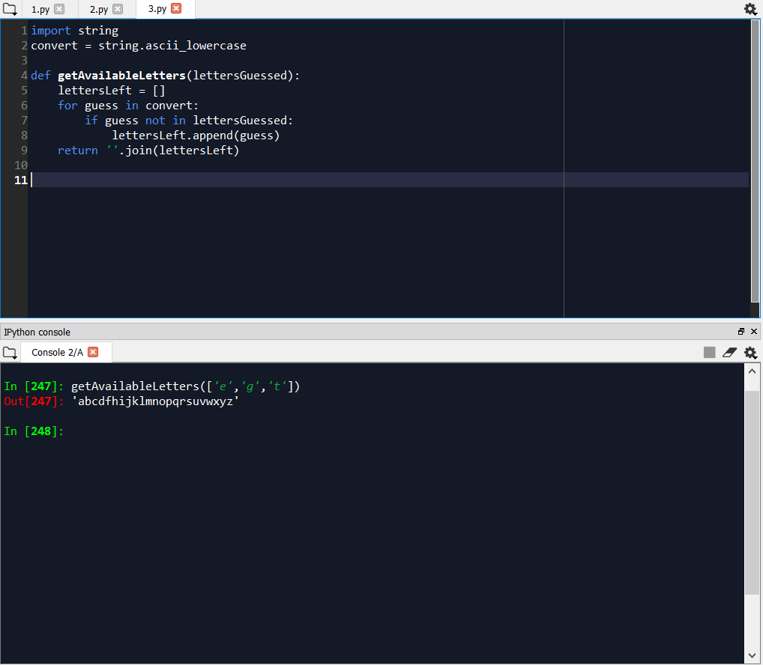

Letters omitted: ‘e’, ‘g’, ‘t’

-the function getAvailable letters pulls out certain/particular letters from a set of letters, and outputs the unused or letters that remained.

**Condition 4:**

**A.**

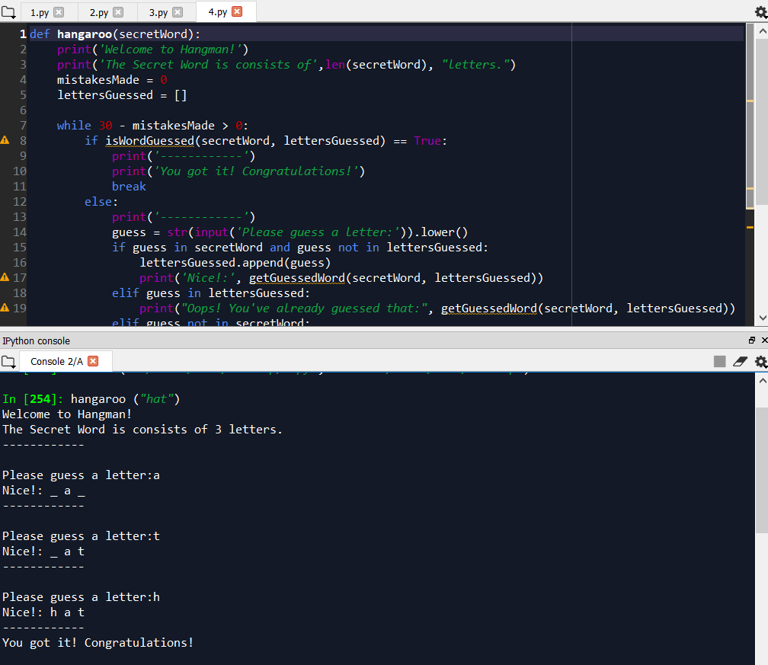

Word Used: hot

-when a letter is correctly guessed by the user, it displays the partial word wherein the correct letters have replaced the blanks.

**B.**

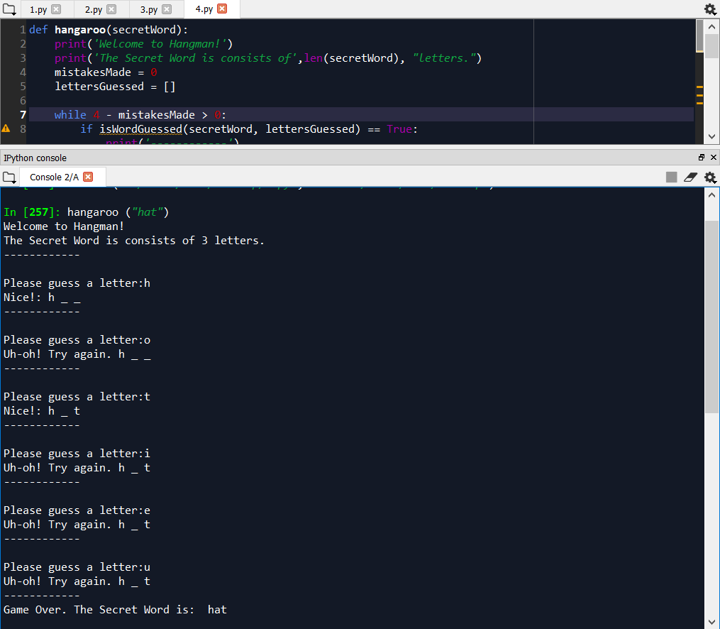

-but when the user guesses a wrong letter, it loops and asks for other letters, leaving the unguessed letter on the word blank.